KENDRIYA VIDYALAYA SANGATHAN

CLASS-III EVS
OBSERVATION & REPORTING
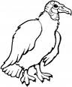
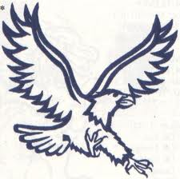
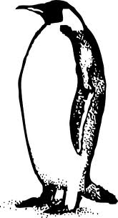
- Name the following pictures.

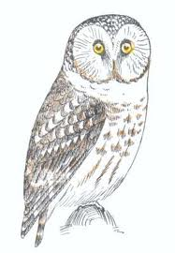
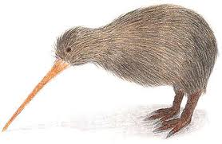
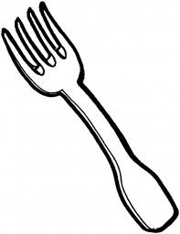
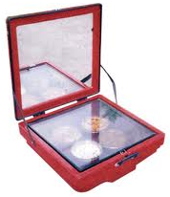
___________________ _________________ _________________

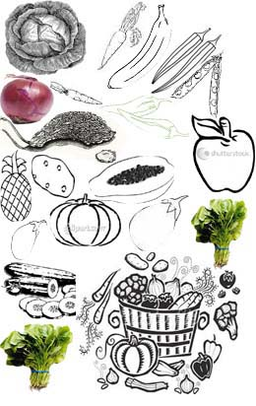
____________________ ____________ __________ ____________
- Answer the following.
- Name four things that are eaten raw.
__________________ __________________
__________________ ___________________
- Name four things that are eaten cooked.

__________________ __________________
__________________ ___________________
Name the items prepared from RICE and WHEAT in the given boxes.
i)
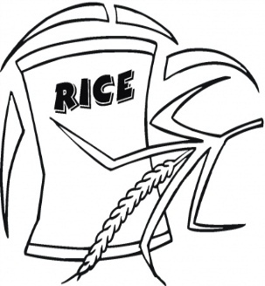

ii)

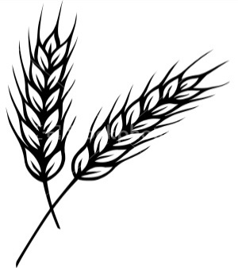
WHEAT

IDENTIFICATION & CLASSIFICATION

- Fill in the blanks using the words given.
( farmer, teacher, doctor, barber, postman )
- A person who cuts our hair is called a __________________.
- a person who grows food in fields is called a __________________.
- A person who treats patients is called a __________________.
- A person who brings letters to us is called a __________________.
- A person who teaches in school is called a __________________.
- Answer the following.
  - Name two vehicles that are used to go over water?
i)_________________________ ii)______________________________
  - Name two vehicles that run in the sky.
i)_________________________ ii)______________________________
  - Name two vehicles that run on land?
i)__________________________ ii)_____________________________
  - Name two big trees.
i)________________________ ii)__________________________
  - Name two sources of drinking water.
i)_________________________ ii)_________________________

- Classify the following into two groups. i) that run on fuel and ii) that need no fuel to run

Bus Tonga Car Cycle Auto- rickshaw

Aero plane Bullock-cart Train Cycle rickshaw Boat

i) that run on fuel ii) that need no fuel to run

________________________ __________________________
________________________ __________________________
________________________ __________________________
________________________ __________________________
________________________ __________________________

DISCOVERY OF FACTS (20)

[
  - In the maze given below encircle five sources of water and write them in the
W | A | T | E | R | F | A | L | L | L
P | G | A | L | I | S | E | A | C | R
O | F | P | M | V | L | A | K | E | D
N | L | E | W | E | L | L | E | C | M
D | A | S | P | R | I | N | G | U | I
R | A | I | N | S | T | R | E | A | M
blanks given below.

What are the sources of water that you got in the maze
  - Do as directed.
    - Name the picture and white what work do they do?
PICTURE | NAME OF THE PROFESSIONALS | WORK THEY DO
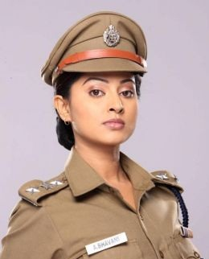 | _____________________ | ___________________________  ___________________________
 | ____________________ | ___________________________  ___________________________

    - Name the picture and white what is it used for?

PICTURE | NAME OF THE VEHICLE | USED FOR
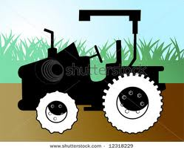 | tractor | to carry goods  for farming
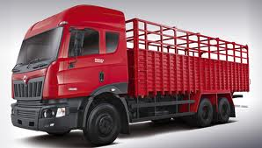 | ____________________ | ___________________________  ___________________________
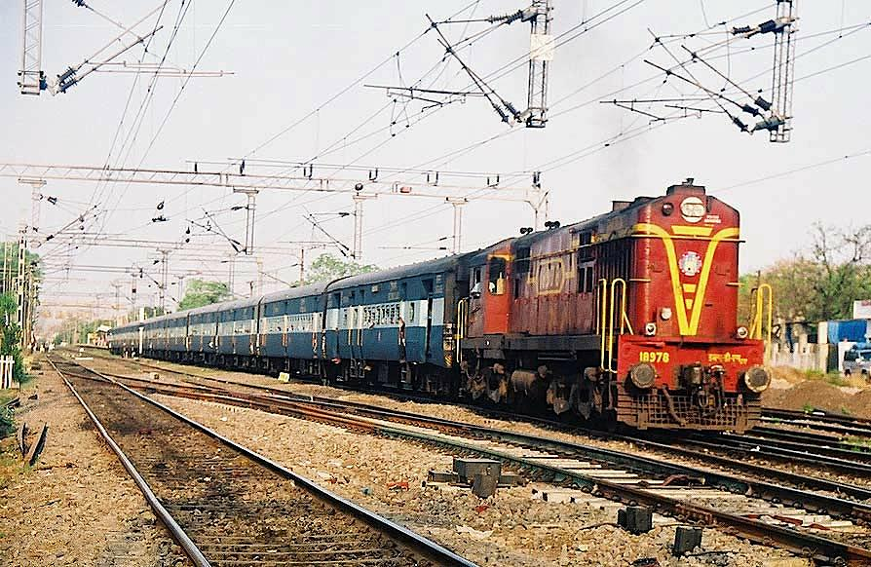 | ____________________ | ___________________________  ___________________________
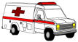 | ____________________ | ___________________________  ___________________________

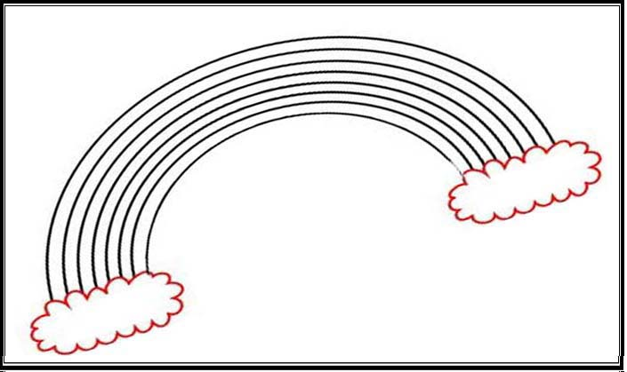
  - Colour the rainbow in proper order and answer the questions that follow.

- When do you see a rainbow ?
_____________________________________________________________
- Where to you find a rainbow ?
_____________________________________________________________
- How many colours do you find in a rainbow?
_____________________________________________________________

